KSCP Ashford Conservation



Volunteers

**Welcome to the Summer Ashford Volunteer Programme.** We run conservation tasks every Wednesday. Details that you need to know prior to task days appear overleaf. Please note that task venues may change without warning, therefore please ring our office first if you are planning to meet the team on site!

**Tel office: 03000 410900**

**Mob: Di 07740 185223 / Debbie 07872 834135**



|  |  |  |
| --- | --- | --- |
| **DATES** | **Venue & Task** | **Grid Ref** |
| Oct 4 | **Watercress Fields** Bay desilting and bank restoration | TQ997 422 |
| Oct 11 | **Watercress Fields** Bay desilting and bank restoration | TQ997 422 |
| Oct 18 | **Godinton ©** | TQ 979 439 |
| Oct 25 | **Godinton © poss tree planting nr sch** | TQ 979 439 |
| Nov 1 | **Bybrook Nature Reserve** – site maintenance ABC Housing £ | TR 014 442 |
| Nov 8 | **Givaudan – tree thinning / barn owl box …** |  |
| Nov 15 | **Buxford –** coppicing | TQ 990 422 |
| Nov 22 | **Dering Wood (1/5)** | TQ 900 447 |
| Nov 29 | **Willesborough Dykes – reptile habitat management** |  |
| Dec 6 | **Dering Wood (2/5)** | TQ 900 447 |
| Dec 13 | **Buxford** – coppicing | TQ 990 422 |
| Dec 20 | Christmas preparations and fun **(Benacre? ½ task)** | TQ 947 439 |
| Dec 28 | Have a fabulous Christmas break |  |

**Volunteer Information**

Pick up details (please get in touch to advise of pick-up in advance!)

* 09.30 pick-up from the Stour Centre Car Park by Sk8side (Nr. Ashford Domestic Station)

You can expect to be back at the Civic and Stour Centre car park by 4.15pm, although this may vary slightly especially in the winter. If you would like to make your own way to the work site, please ring to confirm details.

**What to bring:** Make sure you bring a packed lunch and a drink. It is advisable to wear strong footwear with a suitable firm sole with good grip. Steel toe capped boots must be worn by those using heavy machinery and strimmers/brushcutters. Work gloves will be provided. In the summer it is a good idea to bring a sun hat and sun cream. In winter be sure to wear plenty of warm clothes and remember your waterproofs!

**Health and Safety:** As mentioned above, in summer guard yourself against the sun and bring plenty of cold drink – dehydration is a serious consideration at this time of year. There will always be at least one First Aider on the work task. Safe and responsible use of tools is emphasised by the group leader. If you have any particular medical conditions, or are on medication, please make sure this information is given in the volunteer form and let the group leader know at an appropriate moment. Volunteers should also ensure that their tetanus immunisation is up to date.

**Under 16s**: Under 16s are permitted on task if accompanied by a guardian, or on a school placement, and only then if they do not pose any risk to themselves or other members of the group through irresponsible use of tools.

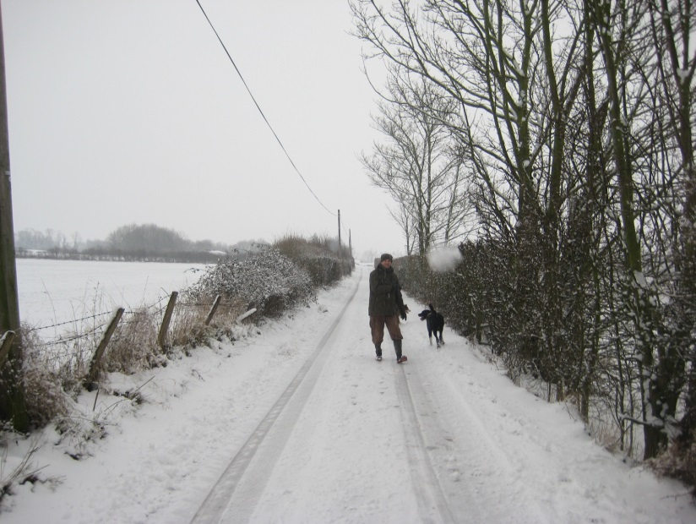

Will it be a winter wonderland this year? Picture taken in Wye February 2009.

The Kentish Stour Conservation Volunteers work on a wide range of projects helping landowners and communities throughout the Ashford District. New volunteers are always welcome – No experience is necessary, as training and guidance will be given on projects by the group leader/and other volunteers. There is also no need to book or obligation to come out. Conservation volunteering is a social and enjoyable way of seeing hidden corners of the countryside and is an opportunity to contribute positively to enhance its beauty and value for wildlife. There is a chance to learn new skills and the work itself can be very rewarding.

**CONTACT: Debbie Reynolds & Diane Comley on 03000 410900 or email** [**Debbie.reynolds@kent.gov.uk**](mailto:Debbie.reynolds@kent.gov.uk) **/** [**Diane.comley@kent.gov.uk**](mailto:Diane.comley@kent.gov.uk)

**Alternatively visit the website at** [**www.kentishstour.org.uk**](http://www.kentishstour.org.uk)

**Kentish Stour Countryside Partnership, Ashford Highways, 4 Javelin Way, Henwood, Kent TN24 8HD**